https://www.sciencedirect.com/science/article/pii/S1532046425000450?via%3Dihub
PLAGCA: Predicting protein–ligand binding affinity with the graph cross-attention mechanism
PLAGCA: deep-learning method for predicting protein-ligand binding affinity. Capturing local 3D pocket interactions between protein and ligand, also using string and sequence features.
Datasets: PDBbind database, CAPLA and Pafnucy. PDBbind has affinity of protein-ligand values. Source 21 splits these values in core, refined and general. Source 22 has an algorithm where you could select the right complex in the core set, by using similarity.
PLAGCA: using graph cross-attention mechanisms, uses multilayer perceptron.
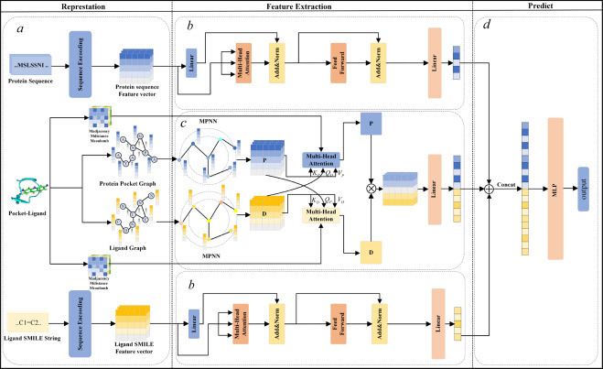
Also mentioned the math behind protein-ligand binding complex representation

https://pmc.ncbi.nlm.nih.gov/articles/PMC2671234/
Computational evaluation of protein – small molecule binding
Class 1: accurate but slow, uses molecular dynamics stimulations. Are in these stimulations represented using a force field. Annihilation, 2 systems are simultaneously simulated using MD. System 1 uses protein and small complex in water and system 2 initially only water molecules. Then it uncouples the small molecule from system 1 and puts it into 2 and measures the free energy change. Seperation, single system of protein and small complex in water. Gradually unbinds the small molecule and then just measures the free energy change.
Class 2: fast but approximate, treats the protein as rigid and replace the water molecules with a continuum description of solvation. Only the ligand degrees of freedom need to be sampled.
I don’t know how much this study is useful.
http://nature.com/articles/s41467-024-54440-6
Interformer: an interaction-aware model for protein-ligand docking and affinity prediction
Interformer: unified graph-transformer model that explicitly models non-covalent interactions.
Proteins and ligand are represented as graphs (atoms=nodes, edges encode proximity/distance). Nodes use pharmacophore atom types as features; edges use Euclidian distance.
Uses mixture-density network (MDN). For each protein-ligand atom pair the model predicts parameters for four gaussian components. The MDN models interaction-specific distance preferences rather than a single generic distance loss.
Generates a pose score and an affinity value, model then produces pose-sensitive affinity predictions.
Uses databases PDBBind and others

Protein embedding: compact way to describe features

Model building:
Features: descriptors, if it works structure.
Protein descriptors: Peptidy features
Ligand descriptors: RDkit features
Features binding: another round of literature search
Model: random forest, boosting forest

Agreements:
Next meeting: 09/12 at 11.00, Arya online.
Evelien: function for descriptors is done, template proposal
Arya: function, one-hot encoding -> descriptors, class protein is done
Iris: 2 functions, uniprot->sequence, sequence->one-hot encoding are done

